NAME: M.VINAY
REG NO: 192311146
COURSE :TOC
CODE : CSA1304

- Design DFA using simulator to accept even number of a’s.
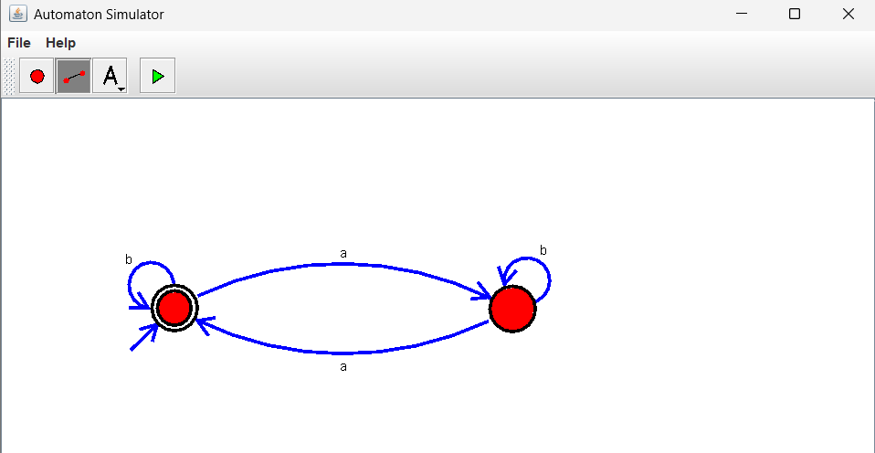
- Design DFA using simulator to accept odd number of a’s
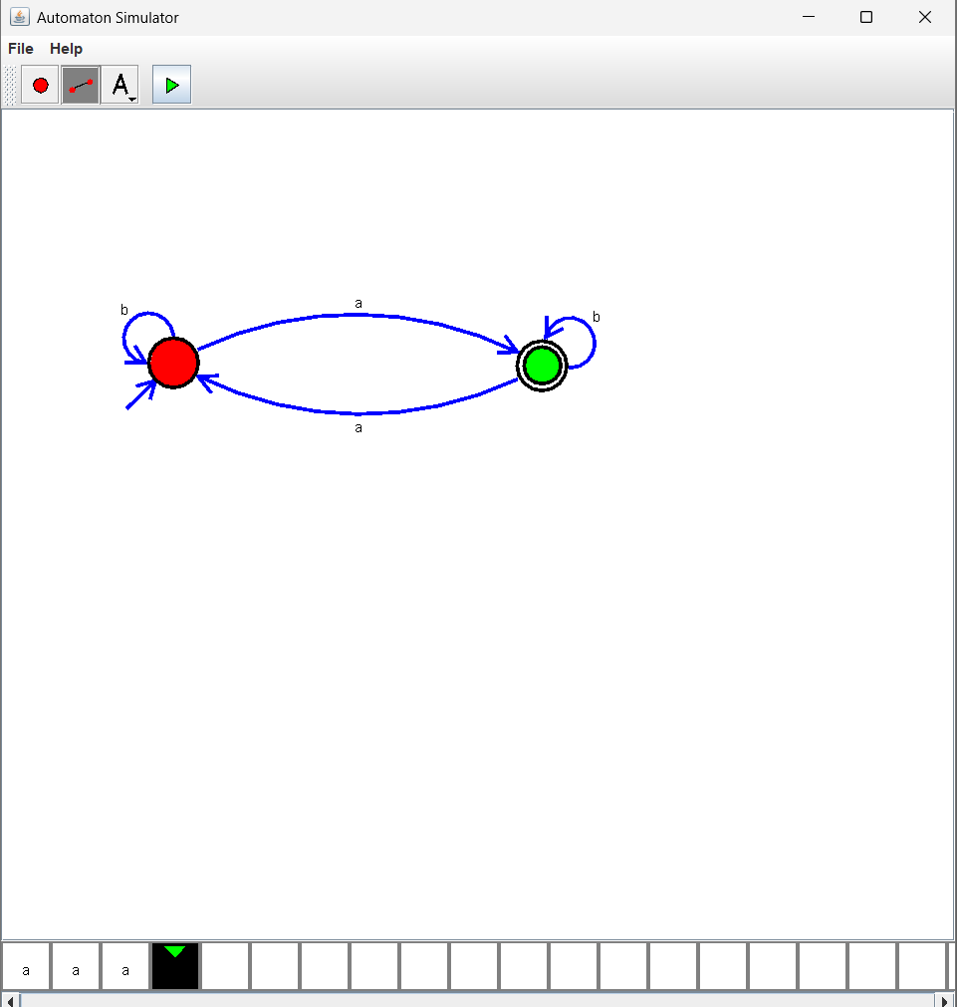

- Design DFA using simulator to accept the string the end with ab over set {a,b) W= aaabab
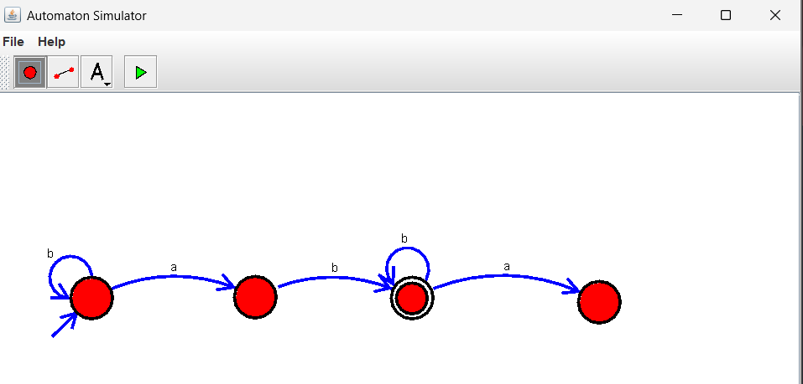
- Design DFA using simulator to accept the string having ‘ab’ as substring over the set
{a,b}
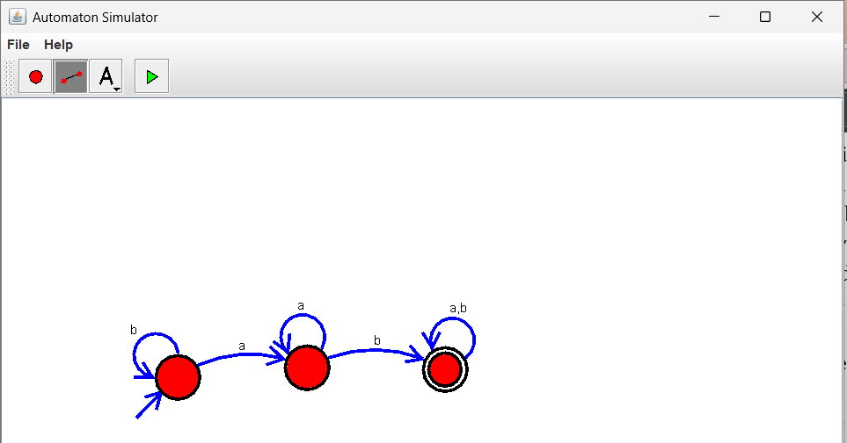
- Design DFA using simulator to accept the string start with a or b over the set {a,b}

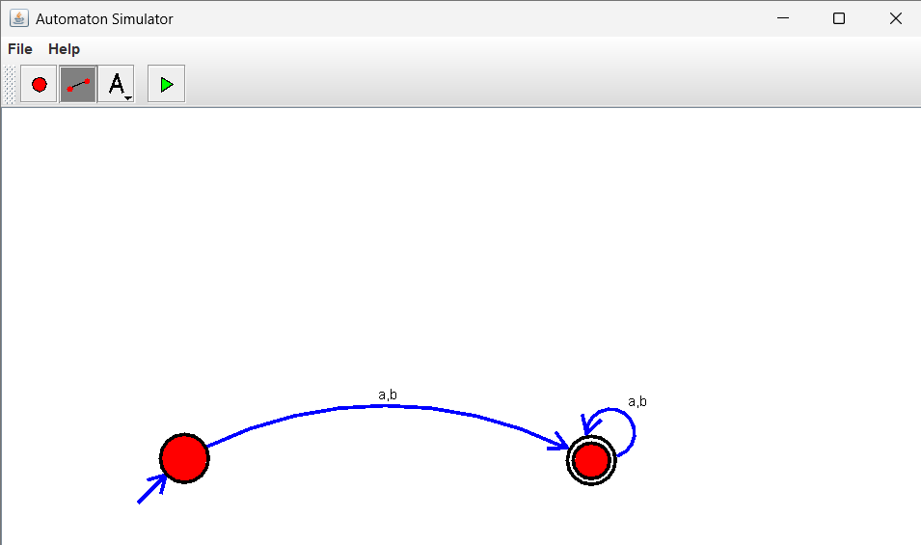
- Design TM using simulator to accept the input string Palindrome bbabb
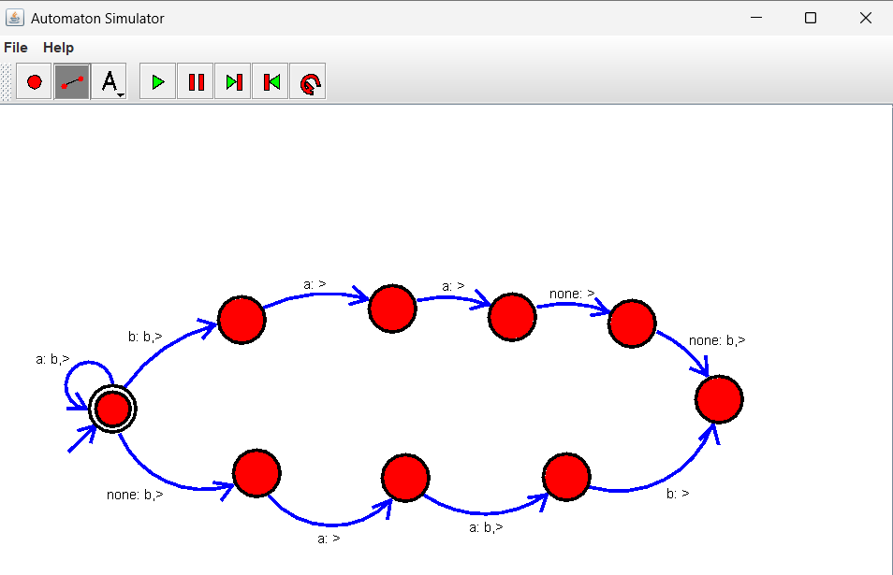

- Design TM using simulator to accept the input string wcw

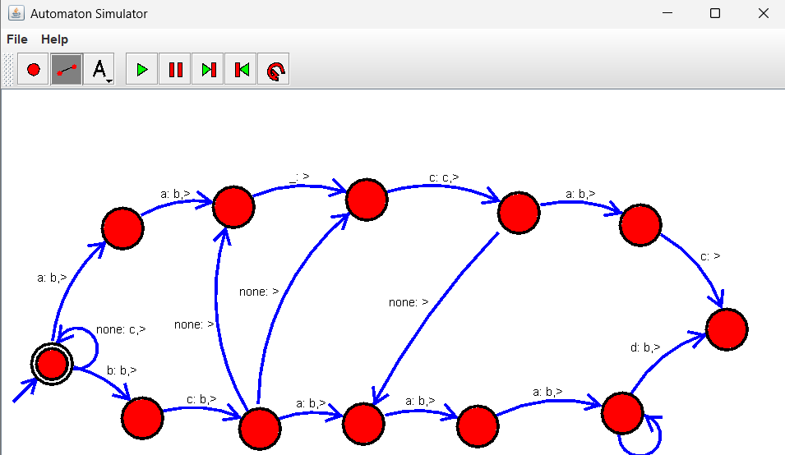
- Design DFA using simulator to accept the string the end with ab over set {a,b) W= abbaabab
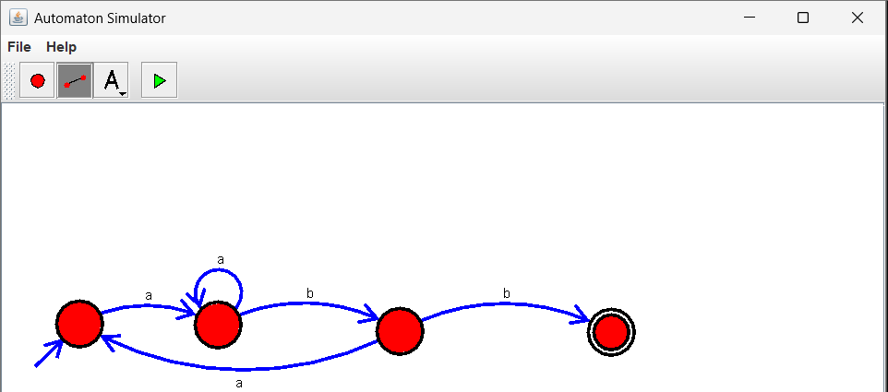
- Design DFA using simulator to accept the input string “bc” ,”c”,and ”bcaaa”.

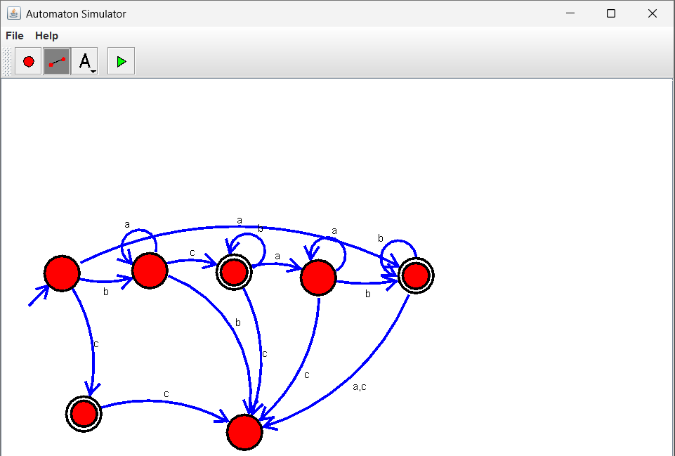
- Design NFA to accept any number of a’s where input={a,b}.
